**Lab 3 Report**

**Pre-lab Exercise**

1. **Introduction**

This pre-lab exercise is part of a larger experiment to design a state feedback control system with an observer for both regulation and set-point control (output feedback control) of a W-T system model. The goal is to become familiar with the system identification process and the properties of the resulting state-space representation.

1. **Objective**

The primary objective of this pre-lab is to recreate the transfer function and state-space models of the identified system from Lab 2, determine if the open-loop system is stable or not, verify if the identified system is a minimum phase system, investigate the reachability (controllability) and observability of the system, and derive the canonical observable form of the state-space model using the duality property.

1. **Procedure**

To achieve the objectives, the following steps were performed:

The provided system identification data from Lab 2 was first loaded and preprocessed. The input and output offsets were removed by subtracting the mean values from the respective signals. The first half of the offset-free input-output data was then used for the analysis.

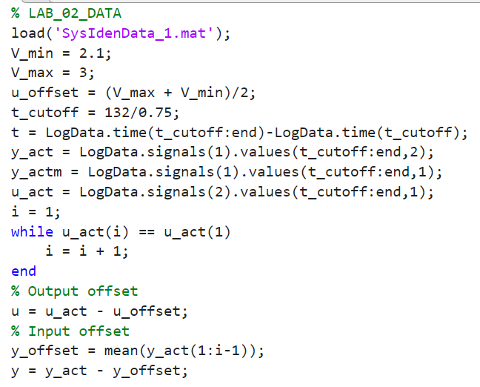

Next, the system parameters a1, a2, b1, and b2 were estimated using a least-squares method. These parameters were then used to construct the discrete-time transfer function G(z) and the state-space representation (G, H, C, D).

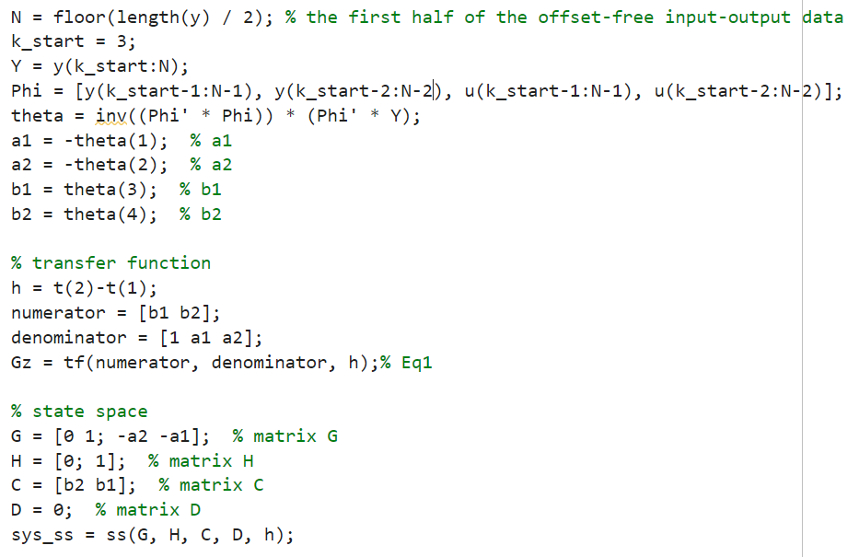

The stability of the open-loop system was determined by computing the eigenvalues of the state matrix G. If all the eigenvalues had magnitudes less than 1, the system was considered stable. The zeros of the transfer function G(z) were also found to check if the system is minimum phase, which requires all zeros to be inside the unit circle.

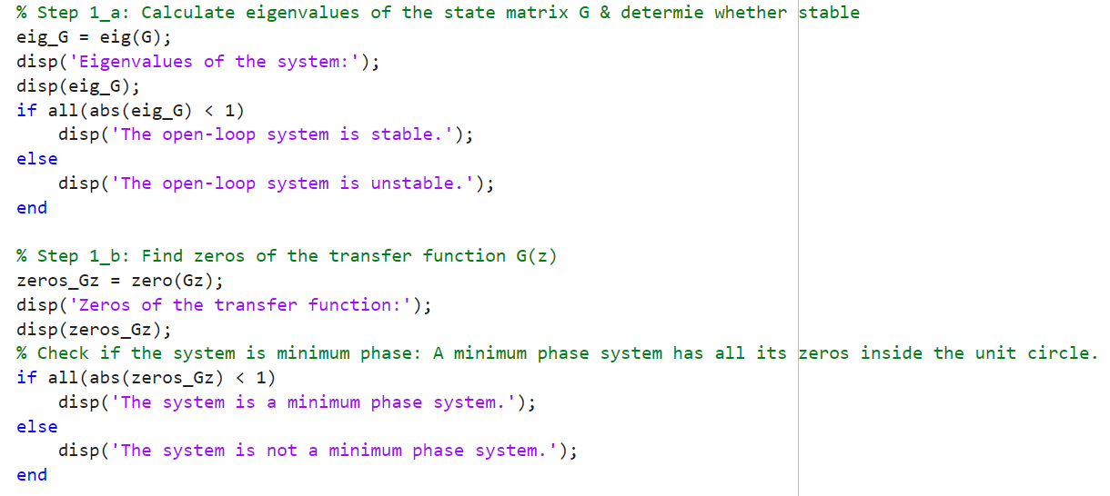

The reachability (controllability) and observability of the system were evaluated by computing the ranks of the controllability and observability matrices, respectively. If the ranks were equal to the dimension of the state-space model, the system was considered reachable and observable.

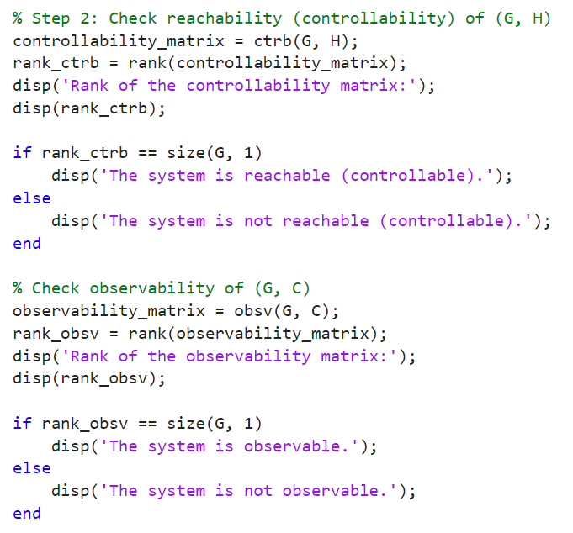

Finally, the canonical observable form of the state-space model was derived using the duality property. This involved transposing the state matrix G and swapping the input and output matrices H and C, respectively.

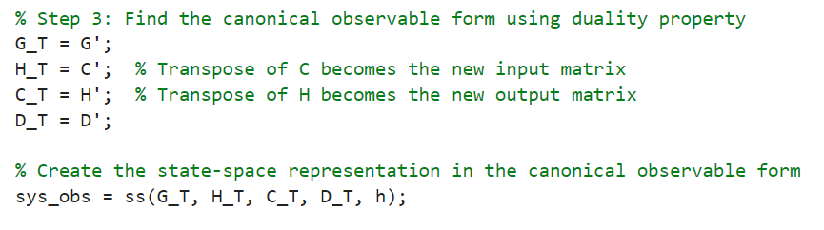

1. **Results and Analysis**

The open-loop system was found to be stable, as all the eigenvalues of the state matrix G had magnitudes less than 1. However, the system was determined to be non-minimum phase, as one of the zeros of the transfer function G(z) was located outside the unit circle. The system was confirmed to be both reachable (controllable) and observable, as the ranks of the controllability and observability matrices were equal to the dimension of the state-space model. The canonical observable form of the state-space model was successfully derived using the duality property.

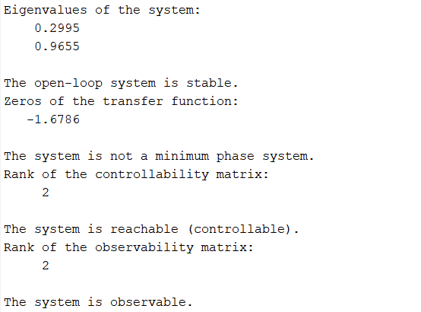

1. Conclusion

The pre-lab exercise has provided a solid foundation for the upcoming lab work. By recreating the system identification results from Lab 2 and analyzing the properties of the state-space model, the groundwork has been laid to design the state feedback control system with an observer. The understanding of system stability, phase properties, reachability, and observability will be crucial in the next stages of the experiment.

**Lab Exercise**

1. **Regulation by state feedback**

According to the requirements in the manual, it is necessary to ensure that y(0) = Cx(0) = 0.3.Then, we can calculate the value of x(0).

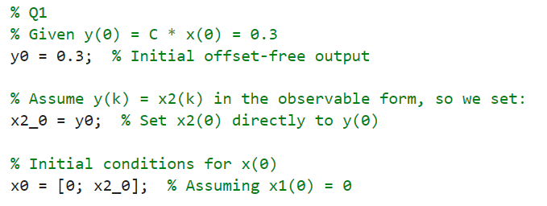

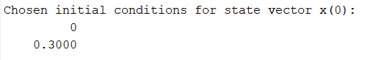

Then, calculate the state feedback gains $L_{db}$ and $L_{ndb}$ for deadbeat control and non-deadbeat control, respectively. Use the MATLAB function *acker* to obtain these feedback gains, and select appropriate closed-loop pole positions as suggested.

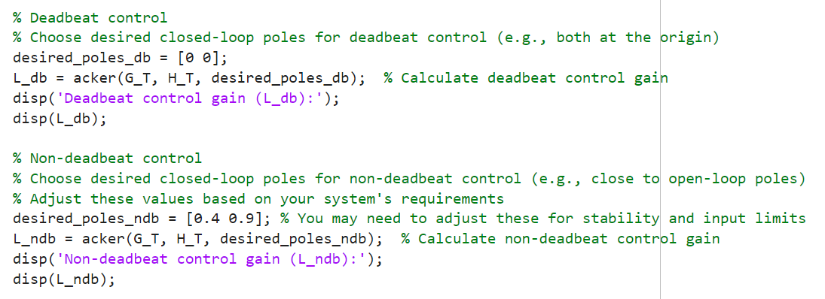

Below are the calculated values of $L_{db}$ and $L_{ndb}$ for the system.

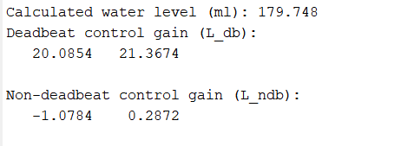

Next, build the responses of these closed-loop control systems in Simulink and observe the performance of deadbeat and non-deadbeat control.

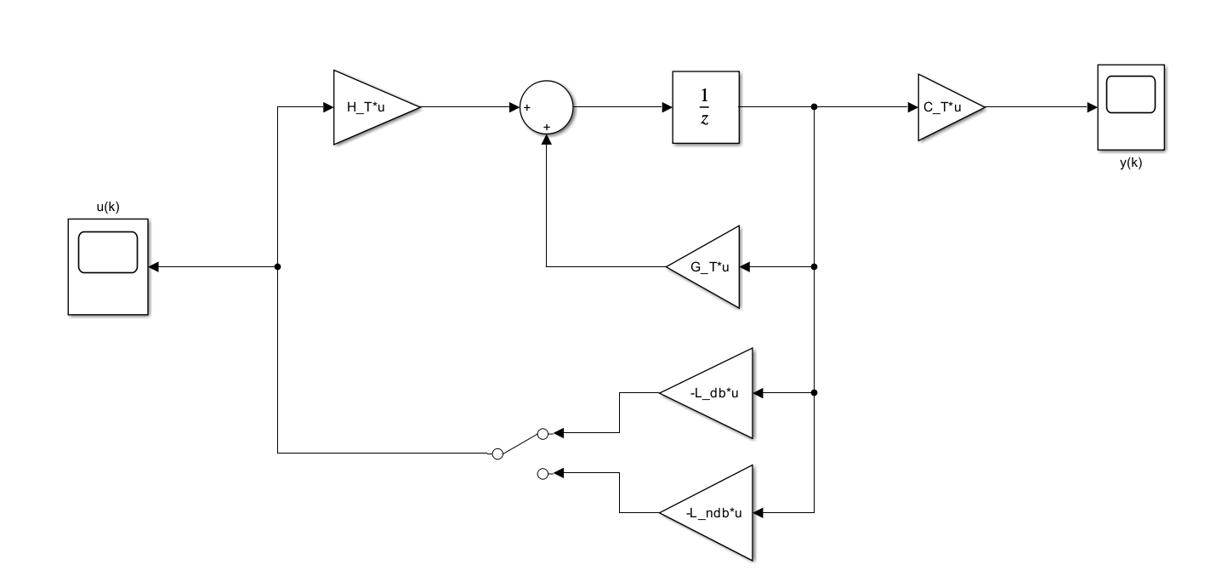

Figure 1. Two closed-loop control model

From Figure 2 and Figure 3, it can be observed that deadbeat control responds faster than non-deadbeat control. However, deadbeat control exhibits overshoot, far exceeding the set threshold of ±0.5V. The overshoot could cause significant damage to the system.

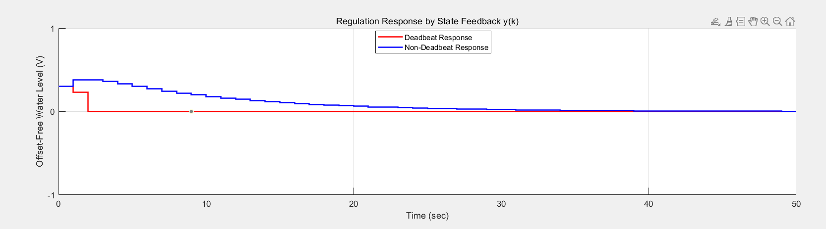

Figure 2. regulation response by state feedback

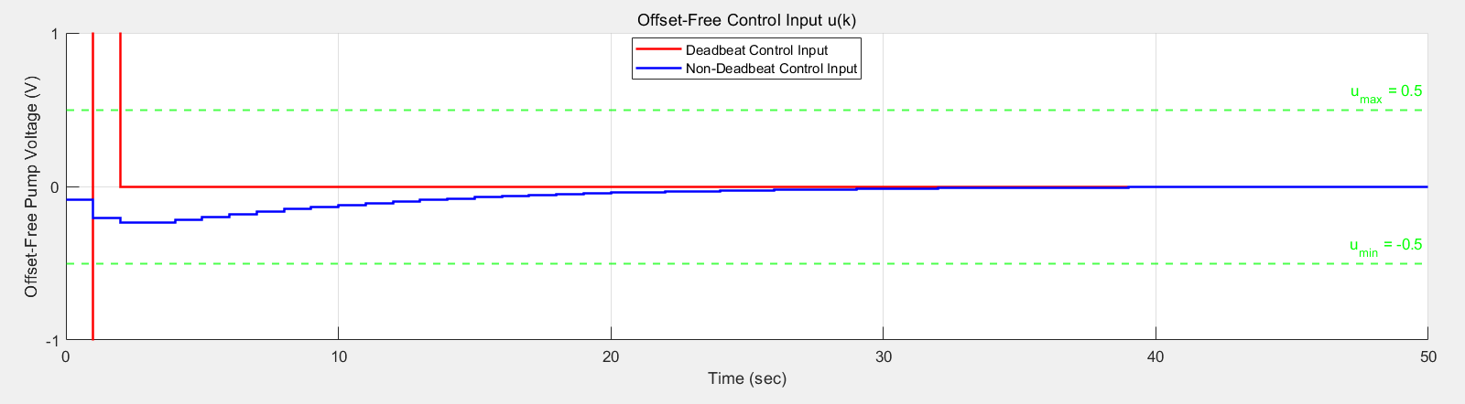

Figure 3. Offset-Free control input

1. **Set-point control**

According to the requirements in the manual, the reference signal for the system is set as {0, 0.7, -0.2, 0.5, 0}, with a period of 140×0.75 = 105 seconds for each level.

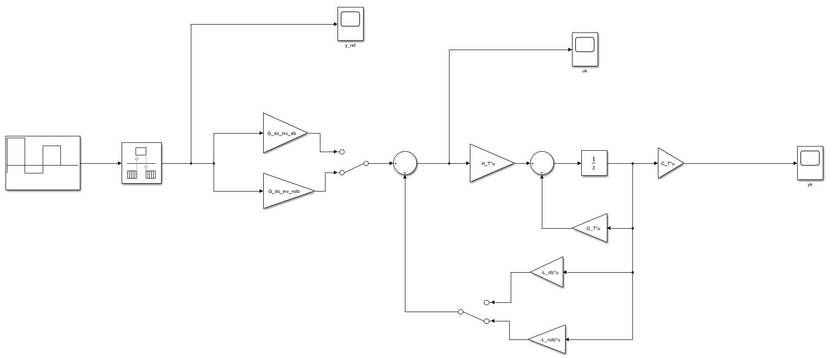

Figure 4. Set-Point Control Model

From Figure 5, it can be observed that the simulated output successfully tracks the reference output, and the control input remains stable within the ±0.5V range.

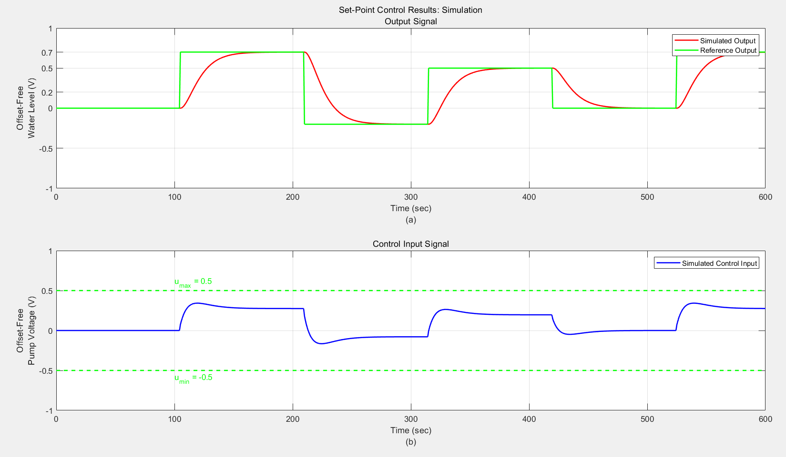

Figure 5. Set-Point Control Model

1. **Output feedback control (Set-point control with observer)**

The following is the simulation model of the output feedback control, and the observer gain is to be determined.



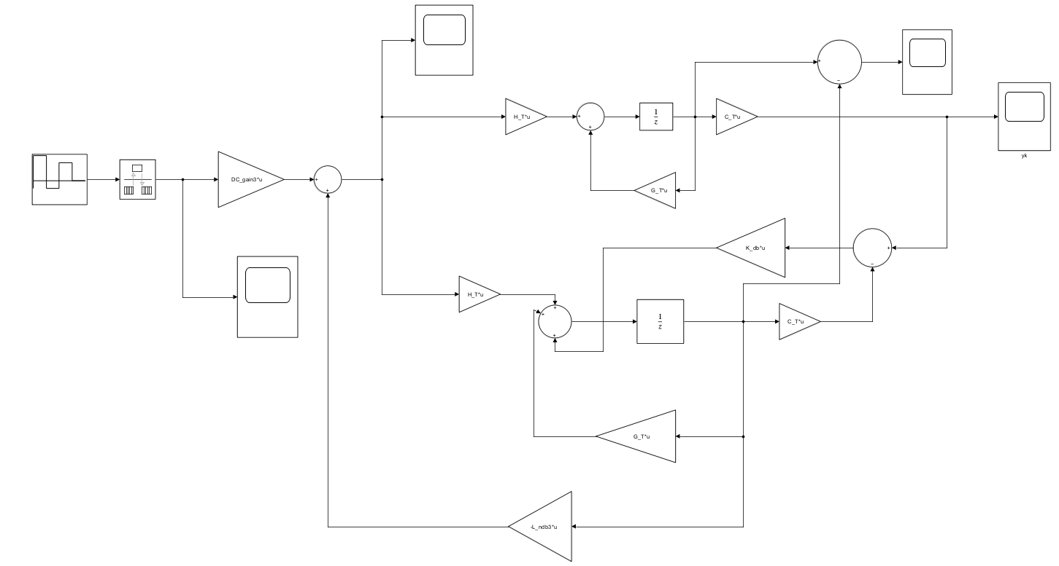

Figure 6. Output feedback control Model

It can be observed that the output response tracks the reference output well, and the input voltage remains within the voltage threshold of ±0.5V. There is a difference in the initial values between the observer and the actual system, but after one sampling period, both converge to the same value.

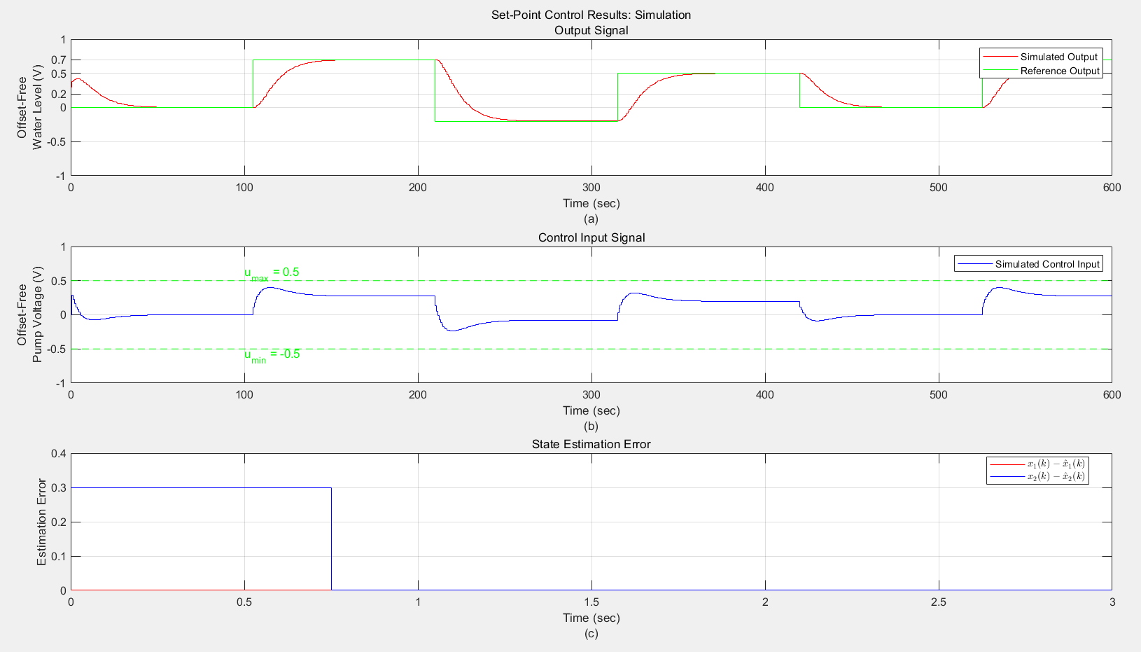

Figure. 7. Set-point control response with observer and non-zero initial conditions, (a) Output response compared with reference output, (b) Control input, and (c) State estimation error.

**Conclusion**

In this experiment, we learned and practiced the process of designing a closed-loop control system using the state feedback approach for a water tank system. First, we calculated the state feedback gains for deadbeat and non-deadbeat control using the Ackermann function and MATLAB's acker() function, and analyzed the system's dynamic response under different control strategies. Next, we used Simulink to build models for the closed-loop control system, set-point control, and output feedback control system with an observer. During the design process, we calculated the observer gain using the duality principle and optimized the control system's performance by combining state feedback and the observer. The results showed that the designed control system successfully tracked the reference output, and the control input remained within the ±0.5V limit, proving the feasibility and stability of the system under the given constraints.

**Post-Lab**